Understanding Well Completion Design

Ahad Momin

The University of Texas at Austin

Petroleum and Geosystems Engineering

Abstract

The objective of this paper is to discuss the process and components required for the completion design of a drilled well. Well completion is the final stage of drilling design to produce reservoir fluids. Completion is an important part of the process, as it is then that all the necessary steps are taken to produce hydrocarbons efficiently. The process includes installing the production casing and perforating it by explosive charges, thereby allowing the fluid flow into the pipe, and eventually into the Christmas tree. This paper will focus on the various components of well completions, such as different types of completions needed, fluids and equipment requirements, types of perforation as well an understanding of artificial lift systems. Several other engineering techniques, such as acidizing and hydraulic fracturing are also performed to increase the production of these natural fluids during the completion process.

Table of Contents

List of Figures 4

Executive Summary 5

What is Well Completion 6

The General Process 7

Types of Completions 8

Completion Equipment 10

Completion Fluids 12

Casing Perforations 12

Artificial Lift Systems 13

Conclusion 14

References 15

List of Figures

*Figure 1*: Stages of well completion 8

*Figure 2*: Open hole completion 8

*Figure 3*: Perforated completion 8

*Figure 4*: Multilateral Completion levels 9

*Figure 5*: Well head and Christmas tree diagram 10

*Figure 6*: Cylindrical perforating gun in pipes 13

*Figure 7*: Artificial Lift Systems 14

Executive Summary

In today’s upstream oil and gas industry, the completion of the well is the most expensive cost framework in the entire hydrocarbon extraction process. To make completion successful and economically beneficial, it is important for an engineer to know all the details and experiences on the field. Completion design starts when the drilling is completed. The general process begins with the placement of the production casing or pipe and cementing it. The casing is then perforated with explosive charges to make a connection between the reservoir and the casing, which allows the hydrocarbons to naturally flow to the surface. If the hydrocarbons do not flow naturally, a lifting system is used to pull the fluid out. To understand the process, it is important to learn the components that make the process run. Several considerations are made to plan the well completion design. A completion engineer determines the type of completion needed, whether the well needs to be an open hole or perforated completion. In fact, geology of the reservoir and the type of rock and sedimentary formations plays an important part in making the decisions about the completion design. The understanding and selection of completion equipment and fluid are also taken into account when the focus lies on the fluid transport. In well completion we also differentiate between the kinds of perforation methods required to make contact. The well stimulations are also executed during the completions, such as hydraulic fracturing to enhance production. All these decisions, planning and choices depend on multiple factors and in-depth mathematical modeling and research, but the goal is to make the process economically beneficial.

Intro: What is Well Completion?

The completion of a well is a broad and complicated process. The term ‘completion’ in the oil and gas industry means to convert the drilled well into a safe and efficient way to produce hydrocarbons. The definition of completion encompasses the interface between the surface equipment, the well, and the reservoir. It is important for a completion engineer to complete the well safely and efficiently by balancing considerations for the environment as well as the economics of the project. The completion process gets more complex as we enter hostile areas like the arctic or deep water. It is a million-dollar design work and all the hydrocarbon production and well ability depends on the completions part. In this paper we will mostly focus on the main part of the completion process and its components. A completion engineer completes a well through a process of determining the type of completion needed, calculating the required completions fluid and equipment, assessing which casing perforations method will work, and finally, by deciding if the well can easily flow up to the surface or if it needs an artificial lift system.

The decision of a completion design depends on several factors such as deciding the kind of equipment to use, selection of certain materials for long activity, establishing production tubing, and evaluating the mode of fluid transport to the surface. In fact, the type of completion required depends heavily on the geology of the reservoir and the type of mineralization. There are two types of completion: conventional and unconventional, or so-called ‘smart completions’.   
 An important element before planning completion is to determine the production characteristics of the reservoir as to whether it is producing liquid, gas or a combination of both, as it is necessary to define pressure, an important part of the fluid mechanics system. Also, it is important to obtain the production capacity data from the reservoir (the permeability, thickness of the productive zone). The production capacity data helps determine the diameters of the casing and the rate at which the fluids can naturally flow. Other factors are also taken into the account when planning, such as a rise in temperature due to the depth, clogging due to solids, and possible future obstructions. Ultimately, the process should be cost effective and efficient; the production rate matters the most.

**The General Process**

Several logging tools and other equipment is lowered to determine the characteristics of the reservoir during the drilling process. After identifying that the reservoir is feasible, the wall of the casing needs to be prepared to allow for the extraction of hydrocarbons, a process known as the completion. The final hole is drilled to reservoir depth allowing the production casing to be lowered into it and cemented into place. The cement requires up to a day of curing time, and must be analyzed before creating perforations to ensure that it holds the casing tightly. After the completion of the final casing, the perforating gun is lowered between the lined well and the outer wall of the reservoir. The gun is fired causing the charges to explode in formation, creating a pathway between the casing and the reservoir. The gun is then removed and the production tubing is lowered, thus ensuring only the flow of hydrocarbons. Depending upon the well and reservoir characteristics, hydraulic fracturing is performed to further crack and open the fractures in the formation, specifically when resources are located within a low permeability shale formation. Fracking increases the fluid flow and enhances production. Although it is not required by every well, hydraulic fracturing is an often used technology in the industry. Other well stimulations may also be utilized, such as acidizing and nitro shooting, to increase productivity. After the well is completed the Christmas tree is installed on the surface and the production of hydrocarbon is started. The production continues for decades, with the help of continuous oil 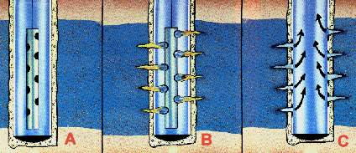recovery techniques and technologies, until the reservoir is emptied. If the fluid is not flowing to the surface naturally, we introduce artificial lift systems, which provide power and lift the fluids to the surface.

Figure 1: Stages of well perforation (Oil on my shoes, n.d.).

**Types of Completions**

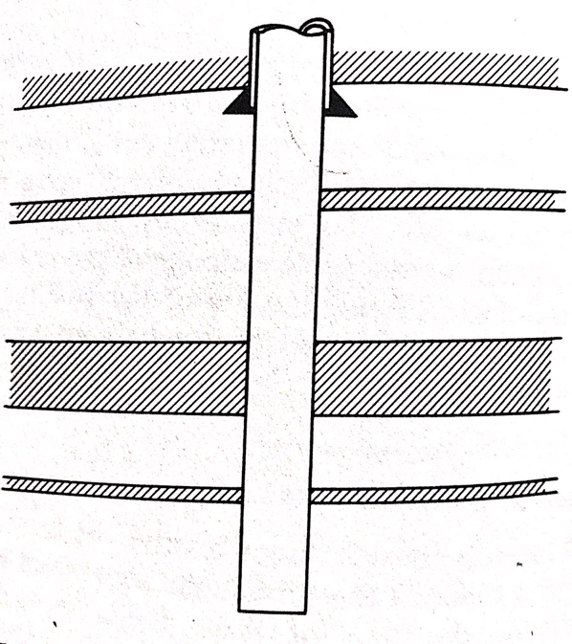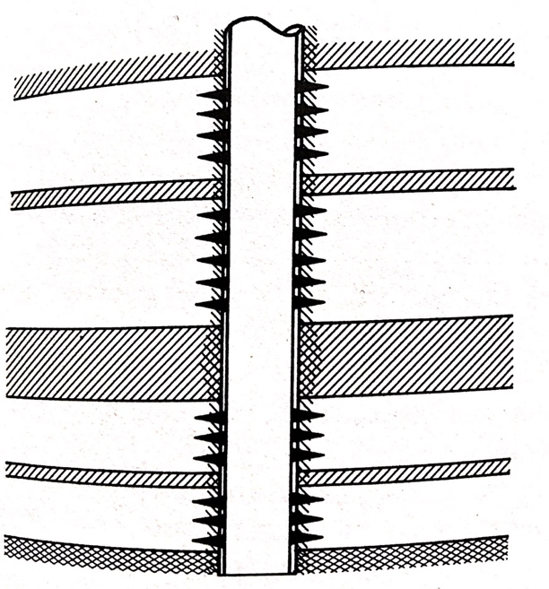There are two categories considered before planning a completion design: open hole completion and perforated completion. Open hole completion is where the casing is set on top of the producing reservoir and no cementing is required. This type of completion is optimal and cheap as the entire drainage system is available for production and pressure drops are limited. However, in this type of completion, it is difficult to control water and sand produced from the reservoir. And It is extremely difficult to isolate their levels, which requires more rig time (Well completions, 2005).   
 The perforated completions are performed by cementing the casing around the producing zone and is then perforated. This completion is widely used as it provides stabilization and excessive water and sand production can be controlled easily. It is adaptable for multiple completion techniques and requires minimum rig time (Thomas & Alan, 1982). However, this method is costly and logging tools are pivotal in this process. It is possible that a poor cementing job can convert the perforated completion to open hole completion.

Figure 2: Open hole completion (Thomas & Alan, 1982).

Figure 3: Perforated completion (Thomas & Alan, 1982).

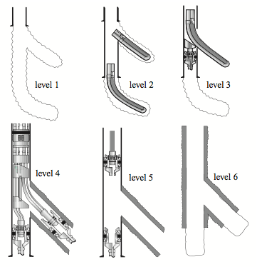The tubing establishes communication between the zone and the surface, to enhance production and avoid corrosive well fluids and high pressures. In single-zone completions, tubeless and packerless completions are normally done. In multi-zone completions, single-string and multi-string methods are required to increase the production rate, increase flow, and provide efficient control. Tubeless completion is used when the productive zone has less pressure and more flow is required. In packerless completion, only the production tube is placed inside the production casing and fluids can flow into both the tube and the annulus. The packerless method is a little dangerous because it is hard to locate leaks in the tube. When there are several productive layers, we use a “system which has only one tubing string, and several packers that isolate the various production levels. By using different engineering operations, it is possible to open and close the valves so as to allow production on single layers” (Well completions, 2005, p. 387). Lastly, we use multi-string completion when we have different mineralization, such as a combination of gas and oil, or different types of oil. The multi-string completion uses two or three tubes, isolated by several packers, and keeps several production zones active.

Figure 4: Multilateral Completion levels (Well completions, 2005).

In the era of directional drilling, the industry has achieved larger production by drilling numerous lateral channels in the same well, which is more cost effective than drilling new wells. Each well is completed, cemented and joined to the central well. Several types of completion are used in the lateral wells, ranging from open hole to perforation, depending on the productive zones. The use of multilateral completions in a single reservoir can increase the efficiency of fluid transport to the surface. In fact, the lateral wells can be drilled in several directions to increase the area in contact with the reservoir, enhancing well productivity and reducing the number of well heads needed for the development of the production field.

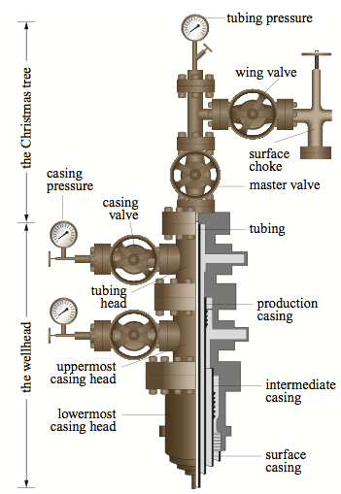**Completion Equipment**

The selection of equipment to meet requirements is necessary for completion design. A wide range of equipment is involved in a well completion, but only the main ones will be discussed. Tubing is the most critical aspect in the completion process. Joint non-welded stainless steel pipe is used for the casing string, which runs from reservoir to the surface. The diameters, length and pipe grades are chosen based on the strength of the pipe and the pressures that it can handle at the bottom of the well. Another alternative to joint steel pipe is the steel coiled tubing. Coiled tubing is used in temporary and long term completion where joint pipes are not an option. Several elements may be added to the tubing, such as flow joints, blast joints and traveling joints, which each have a unique function and help to stabilize the well completion as it is affected by natural factors.  
 Another significant piece of equipment is the wellhead and Christmas tree. The tubing and casing hang and are placed in slots in the wellhead, while the production casing hangs through the bottom. The Christmas tree is placed above the wellhead, and its main function is to provide safe production conditions. It has several valves, which control the fluid flow and pressure during production.

Figure 5: Wellhead and Christmas tree diagrams (Well completions, 2005).

Production packers are an important part of the tubing design. They serve to separate the production area from other parts of the well. “They are used to protect the casing from formation pressure and from the fluids produced, to isolate leaks in the casing or in damaged perforations, to isolate multiple production horizons, to keep production fluids within the annulus, and to enable the use of certain artificial hauling methods” (Well completions, 2005, p. 391). Every packer includes slips, a mandrel, and a cone seat, which are the key foundations towards its installation. Packers are either permanent or removable, depending on where you use them in the tubing. The installation of packers involves pushing the slips towards the inside of the pipe wall in order for them to expand.   
 Subsurface safety valves are another main type of equipment. They play an important part in the pressure control of the well. They are used to stop the production in an emergency, such as a spill. The opening and closing of these valves is controlled on the surface as well they are activated directly inside the well. There are two types of subsurface safety valves: Tubing Safety Valves (TSV) and Annular Safety Valves(ASV). The TSVs control the flow in the tube, and ASVs control the flow between the pipe and the tube, also called the annulus (Well completions, 2005). There is several other equipment used in the process of completion that serve many significant functions, but wellhead completions, packers, tubing, and subsurface valves are the most common and important parts in a completion process.

**Completion fluids**

There are different kinds of fluids involved in the upstream petroleum industry. For completions, we use completion fluid. The term completion fluid describes all the fluids that come in contact with the reservoir. This can include the drilling fluid, the stimulation fluid, and perforating fluids. It is mostly salt or brine solution, which protects the formation from any downhole pressures. The density of these fluids is greater than the pressure in the pore in order to avoid the flow of hydrocarbons during the well completion process. If the fluid is too dense, it could damage the formation, and the hydrocarbons can get lost. The density of fluids is chosen according to the formation pressure. In the petroleum industry, this is called working inside the mud weight window. These completion fluids are tested in the lab before running in the well. The most common salts used in completions are NaCl, KCl and NH4CL (Well completions, 2005). Fluids used for hydraulic fracturing and acidizing are also used as completion fluids, as these fluids come in contact with the reservoir and improve production.

**Casing Perforations**

In perforation completions where the casing is enclosed by the cement, it is necessary to build a connection between the casing and reservoir to initiate the flow of fluids. Hence, we perforate the casing. There are several different kinds of perforation jobs done in the industry. In the 1930s, the bullet perforating method was used, and after World War II, the shaped charges were adapted, and the practice is commonly known as jet perforation. The bullet perforator is essentially a multi-barreled forearm designed to be lowered into a well, positioned at the desired interval, and electrically fired at will from surface controls (Gatlin, 1960). The jet perforating cylindrical gun contains charges. Due to the jet stream’s high velocity, which exerts pressure on the formation, we are able to penetrate through steel and 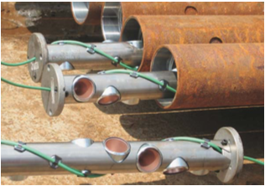cement and into the formation. In comparing the bullet and jet perforation methods, it has been proven that jet perforation is more effective and has a greater penetration ability, but both tools can work for the completion design. Figure 6 shows the cylindrical perforating guns in the casing.

Figure 6: Cylindrical Perforating gun in pipes (Thomas & Alan, 1982)

**Artificial Lift Systems**

Lastly, a completion engineer needs to determine if the fluids from the reservoir will flow naturally to the surface initially or not. If the flow rate and pressures are too small in the reservoir an artificial lift method may be required to move the fluids to the surface and start production. Artificial lifts provide power to the fluids to enable lift. Most oil and gas wells require artificial lift at some point in their life span. Amongst the numerous artificial lift systems are “a) sucker rod pumps; b) hydraulic lifts; c) Electrical Submersible Pumps (ESP); d) gas lifts; e) Progressive Cavity Pumps (PCP)” (Artificial lift, n.d. p. 01). See Fig. 7. The decision regarding which kind of system to use depends on the geological fields and optimal long term costs and production efficiency. The plunger pumps, sucker pumps and gas lift systems are the most commonly used artificial lift systems in the industry as they are resilient, easy to install, and have low maintenance costs (Artificial lift, n.d. p. 01).

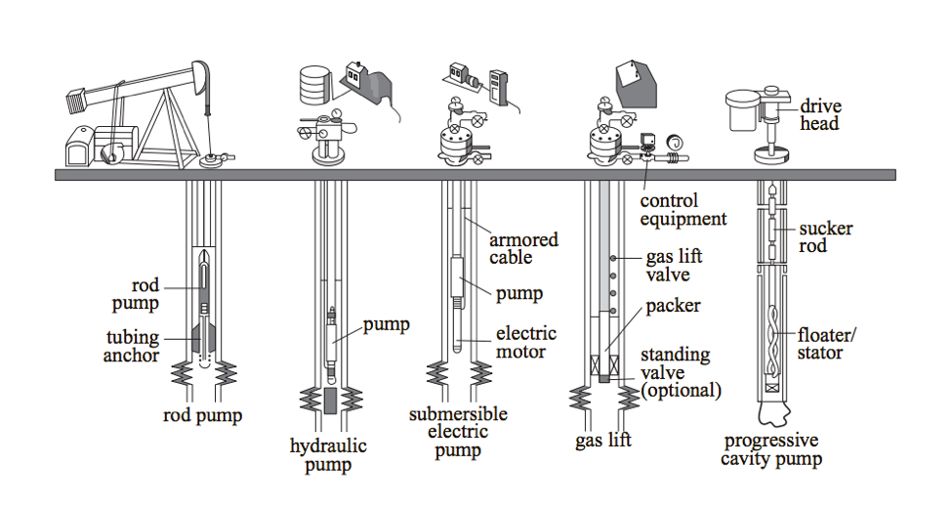**Conclusion**

Figure 2: Artificial lift systems (Well completions, 2005).

Well completion is one of the important program in hydrocarbon production from reservoirs. One might assume it was an easy process when looking at visuals and videos, but in reality a vast knowledge of mathematics, chemistry, physics, transport phenomena and almost all other sciences are required during the process. A completion engineer needs to know not only the general process, different kinds of well completion, material and equipment selection criteria, the completion fluids requirements, determine the perforation method, but also understand well stimulations and artificial lift system methods. Decisions in each category must be planned and tested before the start of completions design taking into account several factors such as reservoir geology, total cost analysis and state requirements. Everything is done within the well economics to ultimately reach the goal of high production with low cost design.

References

Artificial lift. (n.d.). Retrieved November 02, 2017 from the Petro Wiki:

http://petrowiki.org/Artificial_lift

Gatlin, C. (1960). *Petroleum Engineering: Drilling and Well Completions*. Englewood Cliffs,

N.J: Prentice-hall, Inc.

Oil on my shoes. (n.d.). Perforating gun [image]. Retrieved November 01, 2017, from

http://www.geomore.com/completing-the-well/

Thomas, O., & Alan, P. (1982). *Production Operations: Well completions, Workover and*

*Stimulations*. Tulsa, OK: Oil and Gas consulting International, Inc.

# Well completions. (2005). In *Encyclopedia of Hydrocarbons: Exploration, production and transport], Volume 1.* Retrieved from http://www.treccani.it/export/sites/default/Portale/sito/altre_aree/Tecnologia_e_Scienze_applicat e/enciclopedia/inglese/inglese_vol_1/pag385-402ing3.pdf